Changing log

Contents

First prototype 1

2nd prototype 2

Final product 3

# First prototype

At the first the main screen looks like: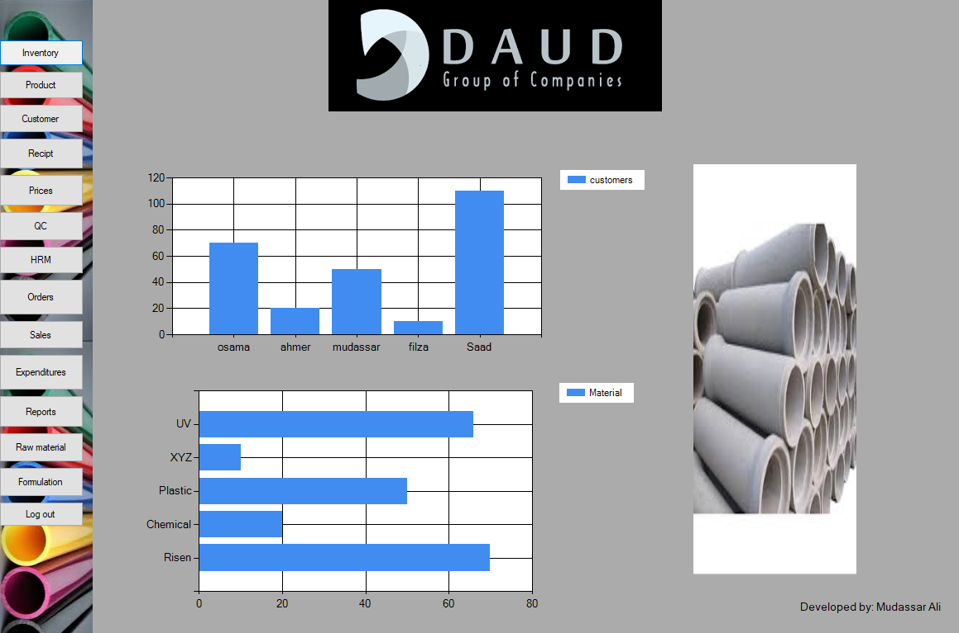

It contains some animation pictures (a slide show at the right side of the screen) and in the buttons panel there was another picture in which all the button were placed.

# 2nd prototype

In the 2nd change the animation was removed and some slight changes were made in functionality with some less button like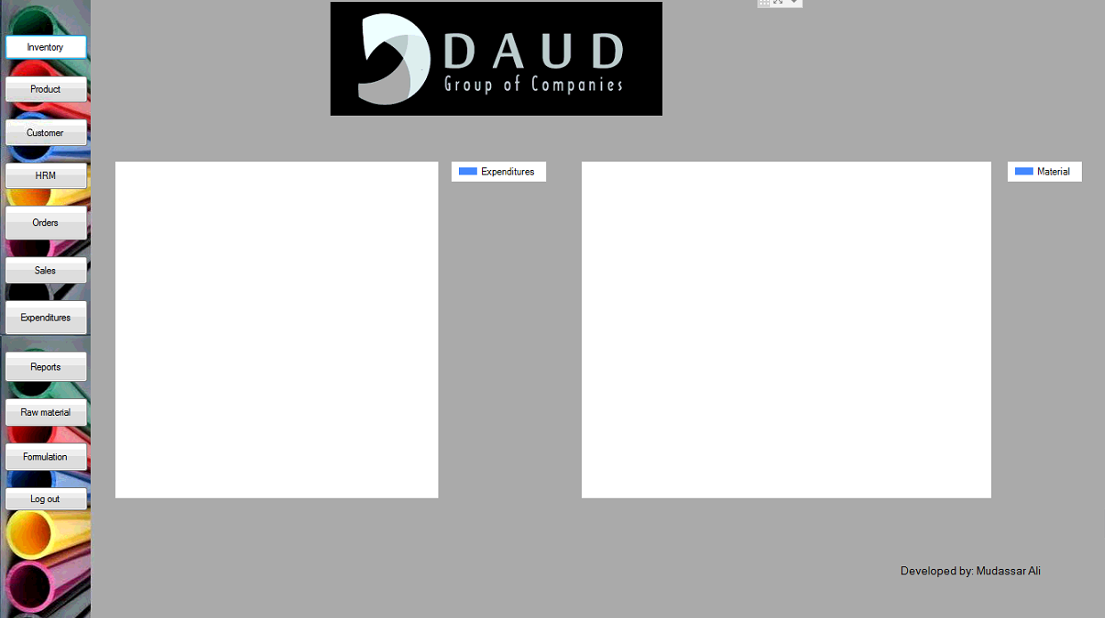

In this phase two charts were side by side with each other and some features were removed like prices which were added in the products table.

# Final product

The final product which is selected by the owner of the Daud group of companies was: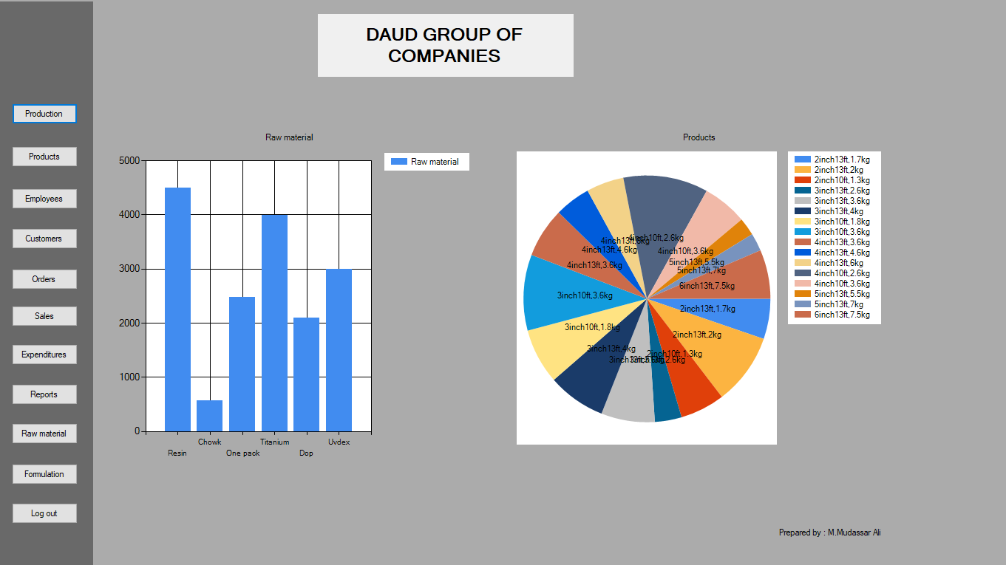

This feature shows graphical representation of products and raw materials at the main screen with almost the similar functionalities as the previous one. In this design a vertical bar chart shows the quantity of raw materials left in the company and a pie chart shows the quantity of products in the company.